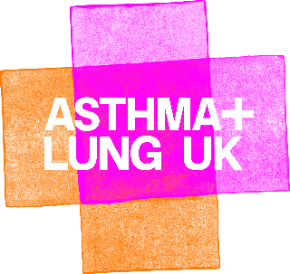

The CLAMP Project
Characterising Leak of Air in Medical Pneumothorax
anthony.martinelli@nhs.net
niki.veale@nhs.net

Letter to Clinical Coding Department

Dear Colleague,

I am contributing to a national NIHR and INSPIRE supported multicentre service evaluation: CLAMP (Characterising Leak of Air in Medical Pneumothorax). This retrospective study aims to assess chest drain removal practices, particularly the efficacy of clamping trials. Prior to project commencement, local Caldecott approval will be confirmed. This project has been classed as a multisite service evaluation by our lead site, Cambridge University Hospitals NHS Foundation Trust. It is not classed as research and further ethical review is not required, as per the HRA decision tool.

Please could I ask for the relevant person/s to perform the following coding search which aims to capture any patient admitted with non-traumatic non-congenital “pneumothorax”:
- Coding Search: Any patient admitted to hospital assigned the ICD-10 code J93 (inclusive of J93.0, J93.1, J93.8, J93.9, in any position) between 01/05/2021 and 31/10/2023

If you have any questions regarding this, please do not hesitate to ask. Many thanks.

Yours faithfully,

